Science Grades 3-4- Ms. Harrison

Last week, I asked you to start a “Field Journal”. Journaling is a great way to help keep your science drawings and other observations in one place and to be able to ask questions about what you have found. In your yard (or looking through the window), choose a particular plant, tree, or area to observe. Record daily changes. Each day record: the date, the weather, and sketches of changes you notice. Have the buds\leaves changed? Are there any animals or more plants growing? What noises do you hear? You could also include previous observations and facts about birds in your Field Journal.

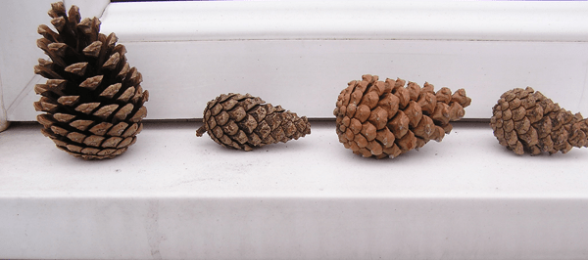
This week’s challenge is to set up pine cone weather station and record daily observations in your field journal.

How to make a pine cone weather station:
Your pinecone weather station can be set up on a window sill outside so you can record what is going on with our pine cones each day. It might be helpful to attach them to the window with some duct tape or modelling clay (anything to secure them to the ledge) so that they don’t fall over as the weather changes. The wind could blow them of the window sill.

In your field journal write this as your experiment hypothesis (is an idea or explanation that you test through study and experimentation).
Test this hypothesis: When the weather is dry the pine cones open up and when it’s going to rain they close down.

Can’t wait for you to share your findings! Please post pictures of your experiment on our DFMS Facebook page.

Pine Cone Facts
Pine cones open and close depending on the humidity to help seed dispersal. Inside the pine cone there are lots of feather light seeds. When the weather is dry the pine cone opens up and any wind will catch the seeds and allow them to be dispersed in the air far away from the original tree.
When the humidity rises and rain is likely then the pine cone closes up to prevent the seeds escaping as being so light the seeds will become water logged and they will travel only a short distance from the original source which would be shaded and have to fight the “parent” tree for resources.
Have a great week & take care!

